  - Brighton Dale 2026
  - JUNIOR GOLF CAMP!

Please join us for our fun four day golf camp. We will have 45 minutes of instruction each day after that the kids can
take to the course to play up to 9 holes. We will cover putting, chipping, full swing, and of course ettiquette.

Junior Name: _______________________Age:________________________

Parent/Guardian Name: __________________________Phone:___________________________

Signature of Parent/Guardian: _______________________ Date: _______________________
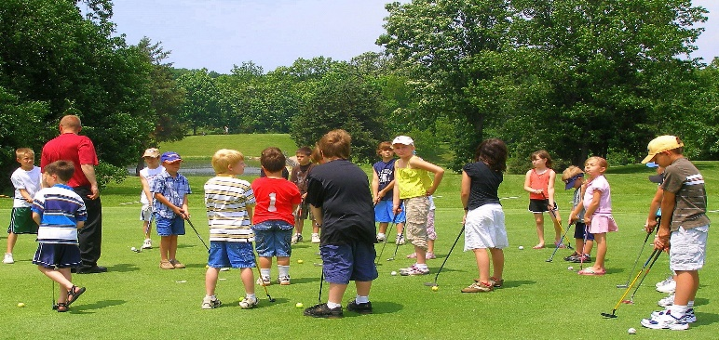
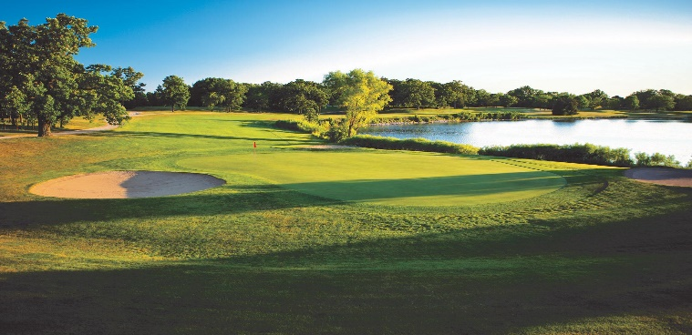

Learning the Fundamentals
August 10th-13th

$150 per Week 5:00pm
Does the participant need clubs? Yes ( ) No ( ) If Yes, Right-handed ( ) or Left ( )
Limited to the first 30 kids

*Each day after instruction, the golfers are welcome to play as much golf as they can for two hours after their class. It is not mandatory but highly encouraged that parents walk along with juniors while they play golf.

